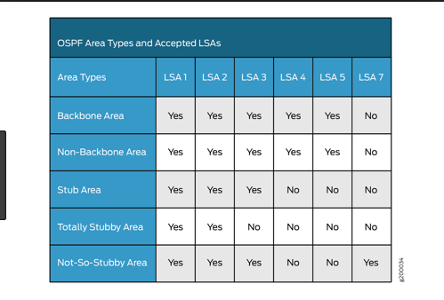

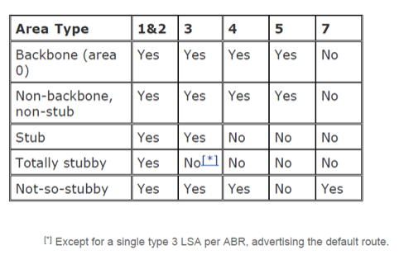

Chapter 3 ppt LSA -Chapter 3 Lab 3-2, Multi-Area OSPF with Stub Areas and Authentication

R2(config-router)# area 23 stub no-summary--🡪 totally stub

R3(config)# router ospf 1 R3(config-router)# no area 23 stub R3(config-router)# area 23 nssa R3(config-router)# redistribute connected subnets --🡪 nssa

R3(config)# router ospf 1 R3(config-router)# area 23 stub🡪 stub area

* By default, the IPv6 MTU must also match between OSPFv3 neighbors. However, you can override this by using the **ospfv3 mtu-ignore** interface command.